Instructions for temporary residence, extension of temporary residence and Single Permit application

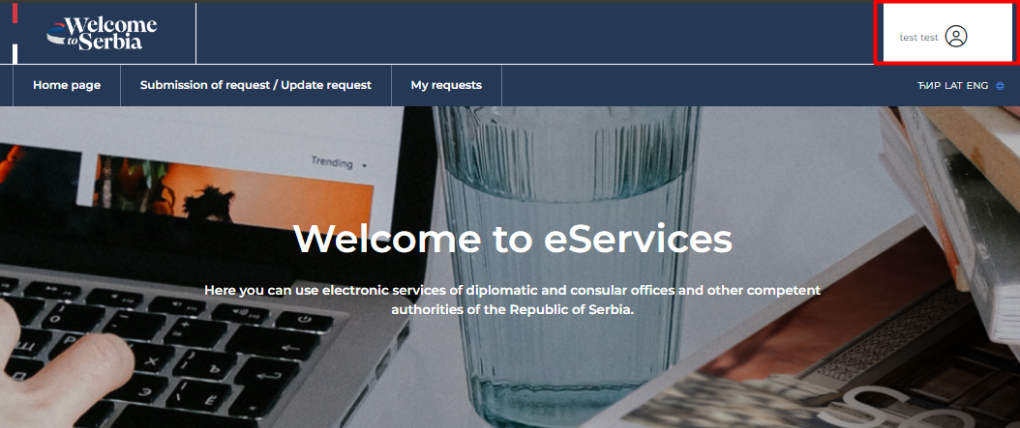
- Temporary residence and extension of temporary residence requests can be submitted via https://eforeigner.welcometoserbia.gov.rs/. It is necessary for the user to log in first.

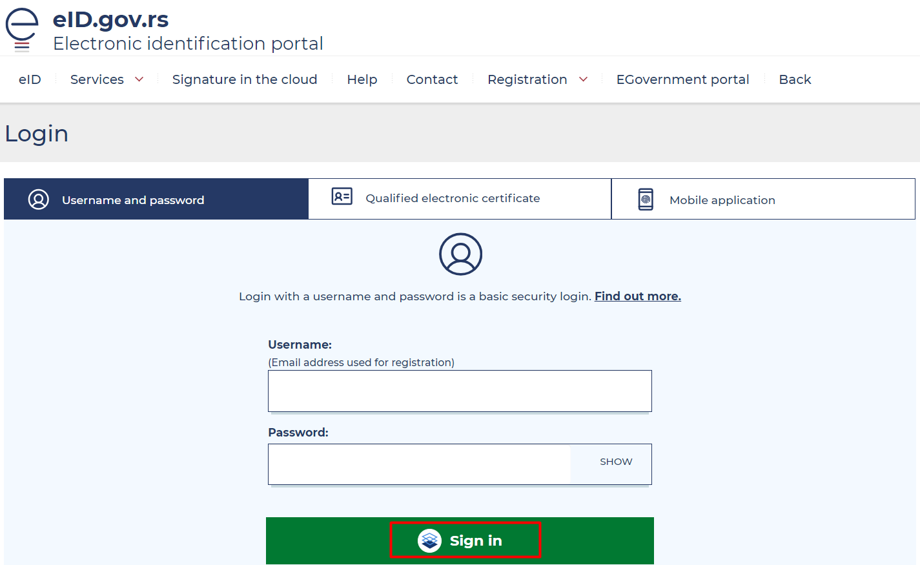

- The user chooses the way they want to log in.
Prerequisite: The user must be registered at https://eid.gov.rs/sr-Cyrl-RS/pocetna
Note: If the user stated during registration that they have an EBS (foreign citizen’s registration number), which is valid at the time of application, it is an extension of temporary stay.
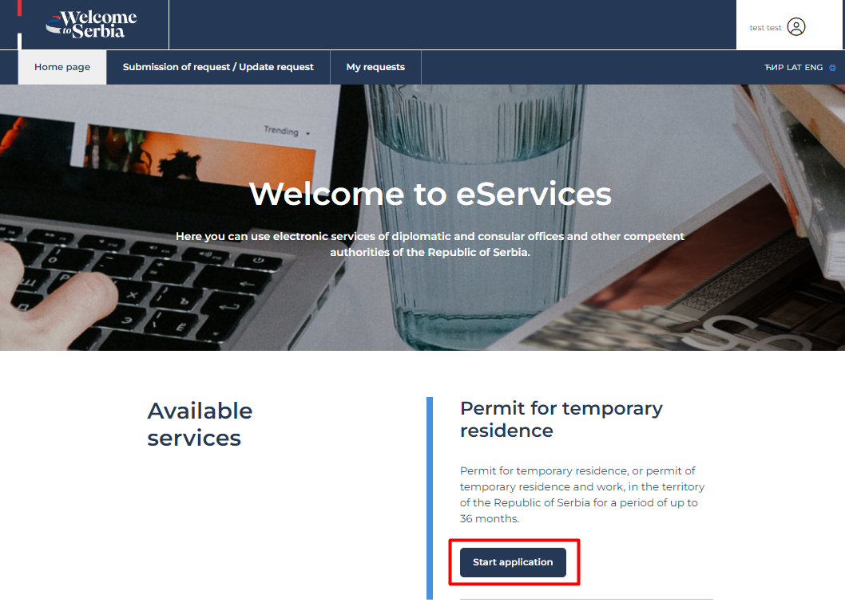

- After successful login to the system, the user clicks the "Start your application" button.

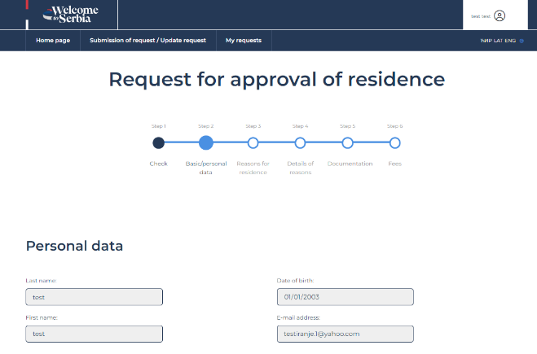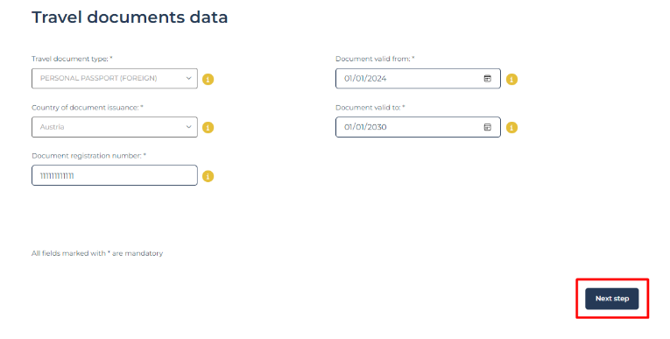

- It is necessary to enter personal data, additional information, data on country and place of birth, as well as data on travel documents.

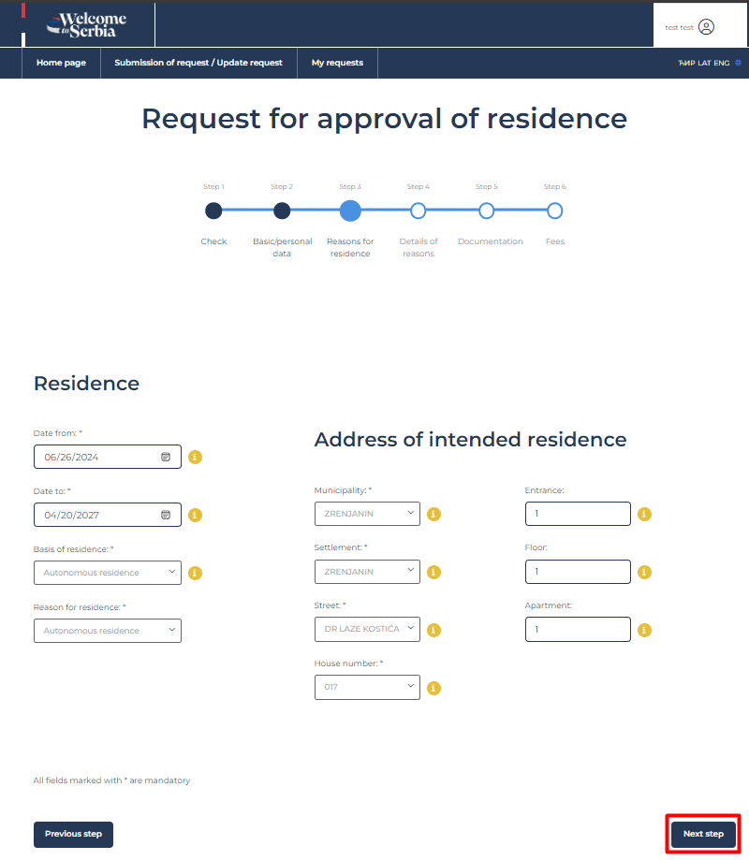

- After entering the information about the stay and the address of the intended residence, go to "Next step".
Note: If you choose employment as the basis of residence, and the reason is employment (in the narrower sense), if you are registered in the decision on registration (self-employment), have a contract on business and technical cooperation (referred persons), perform movement within a company, training and development or you are an independent professional, you are applying for a Single Permit (residence and work).

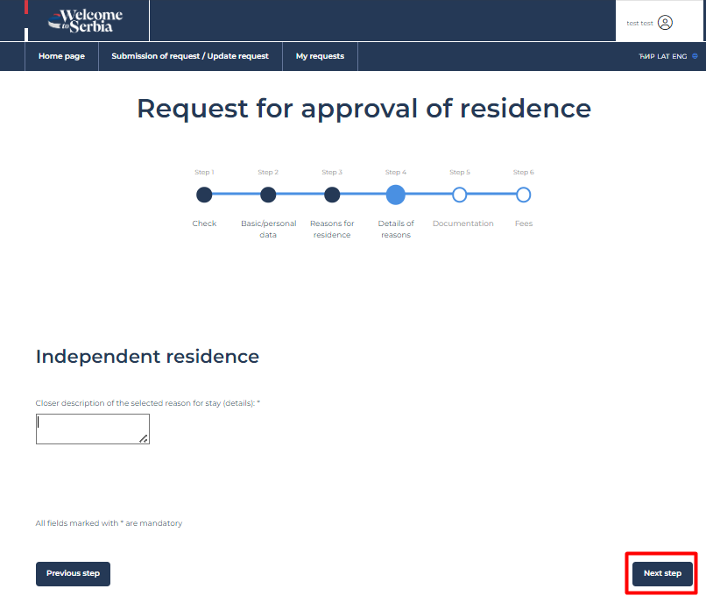

- After entering the details behind the reasons on the previously selected basis, proceed to "Next step".

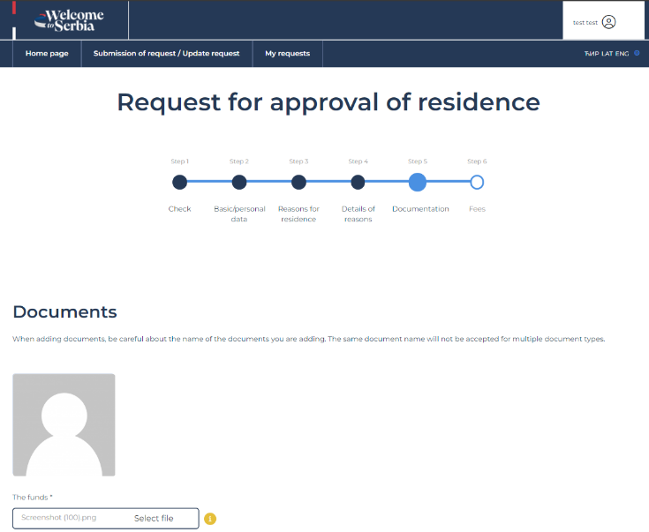
- When attaching required documents, pay attention to allowed extensions (formats in which the requested documents must be submitted) and the size of the documents (up to 5MB). After attaching all the necessary documents, proceed to "Next step".

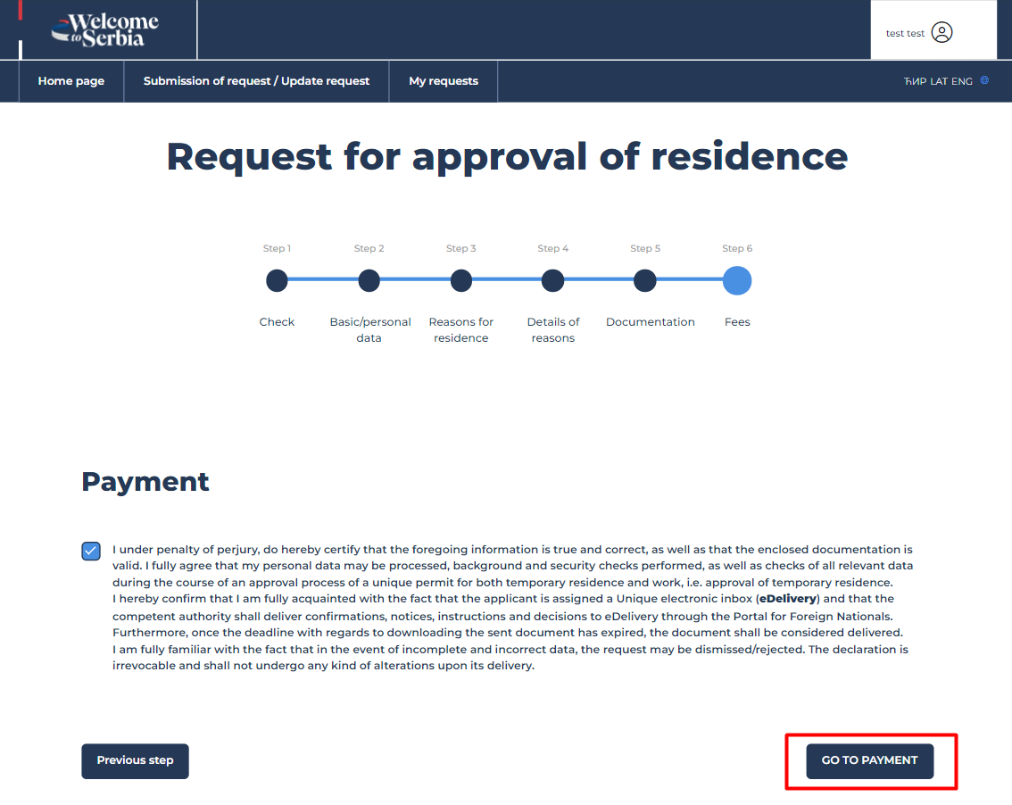

- After giving consent, select "Proceed to payment".

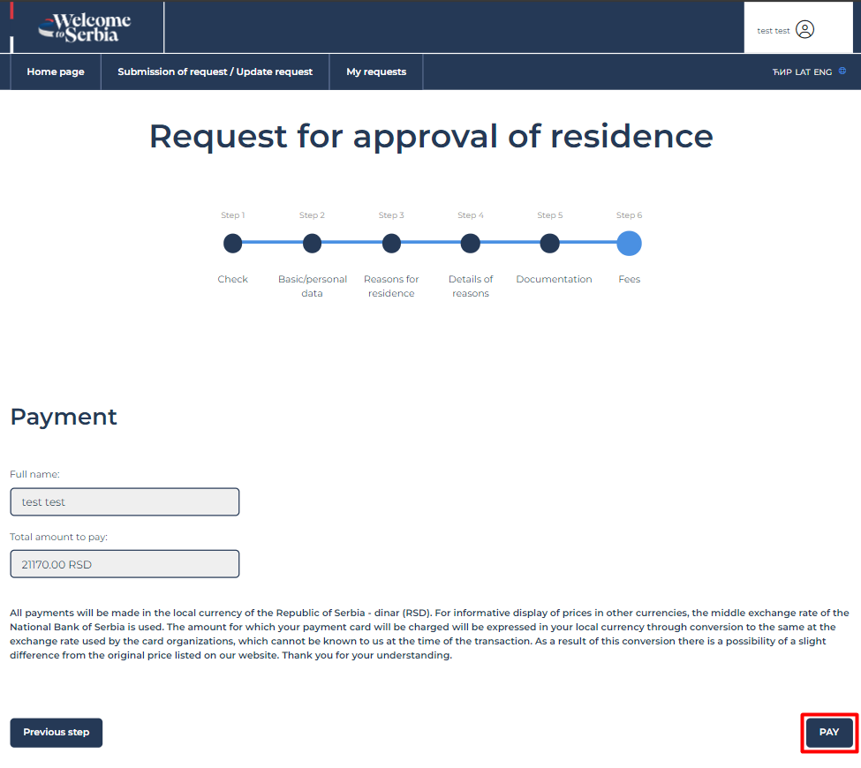
- The total amount to be paid is calculated based on the information you entered when applying.
You can check the status of your request at any time.

